

ANUJ RASTOGI-DV AND BI-GRADED ASSIGNMENT

DEVELOPER NAME: ANUJ RASTOGI

TOPIC: TABLEAU ASSIGNMENT, MIT

COMPLETION DATE: 18TH JAN’24

# SHEET 1: ANNUAL SALES COMPARISON

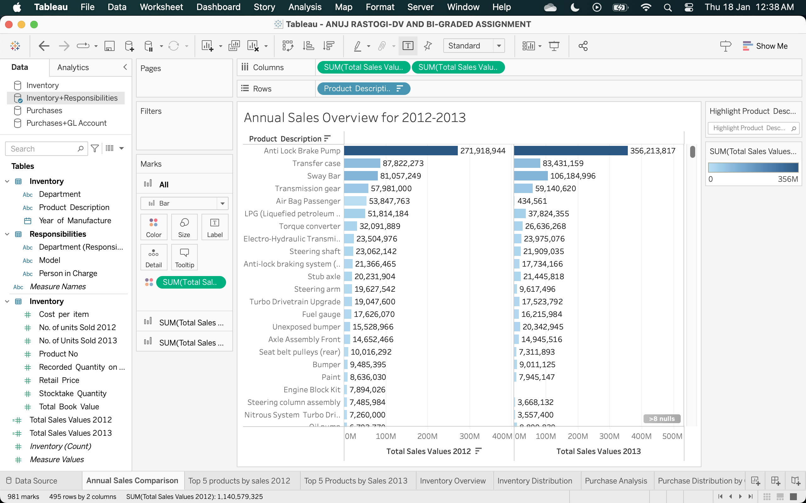

* RENAME COLUMN ‘Total_ Annual_ Sales_ 2012’ TO ‘NO. OF UNITS SOLD 2012’
* RENAME COLUMN ‘Total_ Annual_ Sales_ 2013’ TO ‘NO. OF UNITS SOLD 2013’

# GO TO ANALYSIS AND CREATE A CALCULATED FIELD:

* TOTAL SALES VALUE 2012 = [No. of units Sold 2012]*[Retail Price]
* TOTAL SALES VALUE 2013 = [No. of units Sold 2013]*[Retail Price]

# DRAG:

* PRODUCT DESCRIPTION TO ROWS, TOTAL SALES VALUE 2012 & TOTAL SALES VALUE 2013 to columns
* Drag: TOTAL SALES VALUE 2012 & TOTAL SALES VALUE 2013 to colors

**Insight:** The above graph shows us the year wise sales overview for 2012 & 2013

* **Sheet 2: Top 5 products by sales 2012**

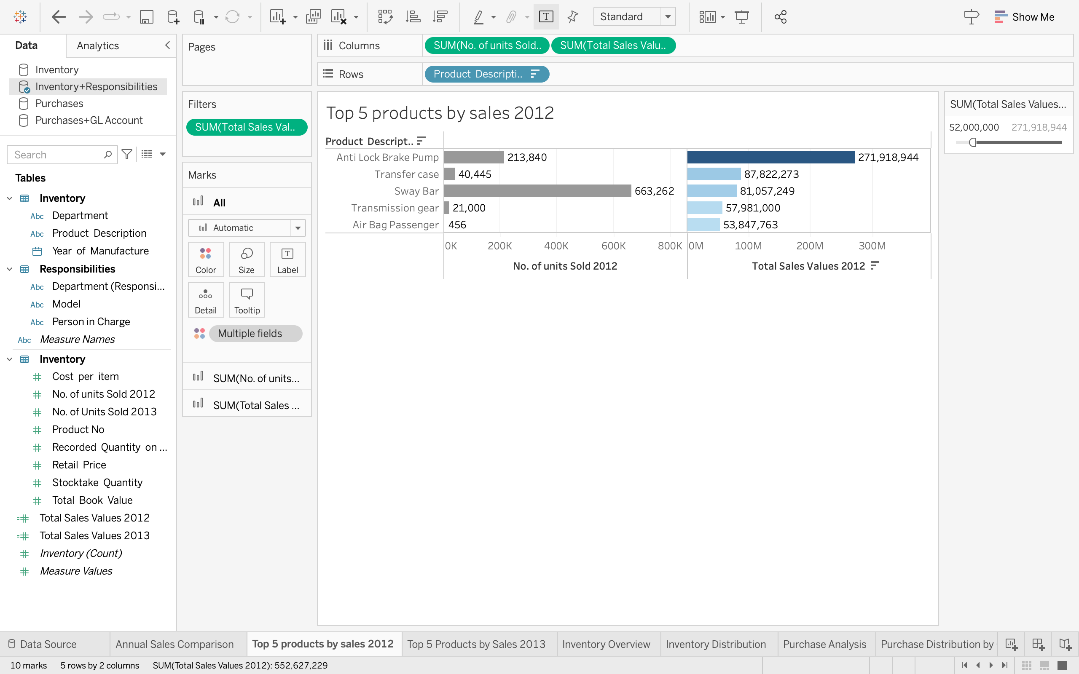

**Drag:**

* ‘Product Description’ to Rows and ‘No. of units Sold 2012’ & ‘TOTAL SALES VALUE 2012 ‘ to columns
* ‘No. of units Sold 2012’ & ‘TOTAL SALES VALUE 2012 ‘ TO COLORS
* CREATE FILTER WITH ‘TOTAL SALES VALUE 2012’ AND SELECT SHOW AT LEAST : ‘52000000’> APPLY>OK
* THIS FILTER WILL ONLY SHOW TOP 5 RESULTS FOR BEST SALES VALUE BY PRODUCTS FOR 2012

# INSIGHTS

* WE CAN SEE THE TOP 5 PRODUCTS BY THEIR TOTAL SALES VALUE FOR 2012 INCLUDING THE NO. OF UNITS SOLD
* **Sheet 3: Top 5 products by sales 2013**

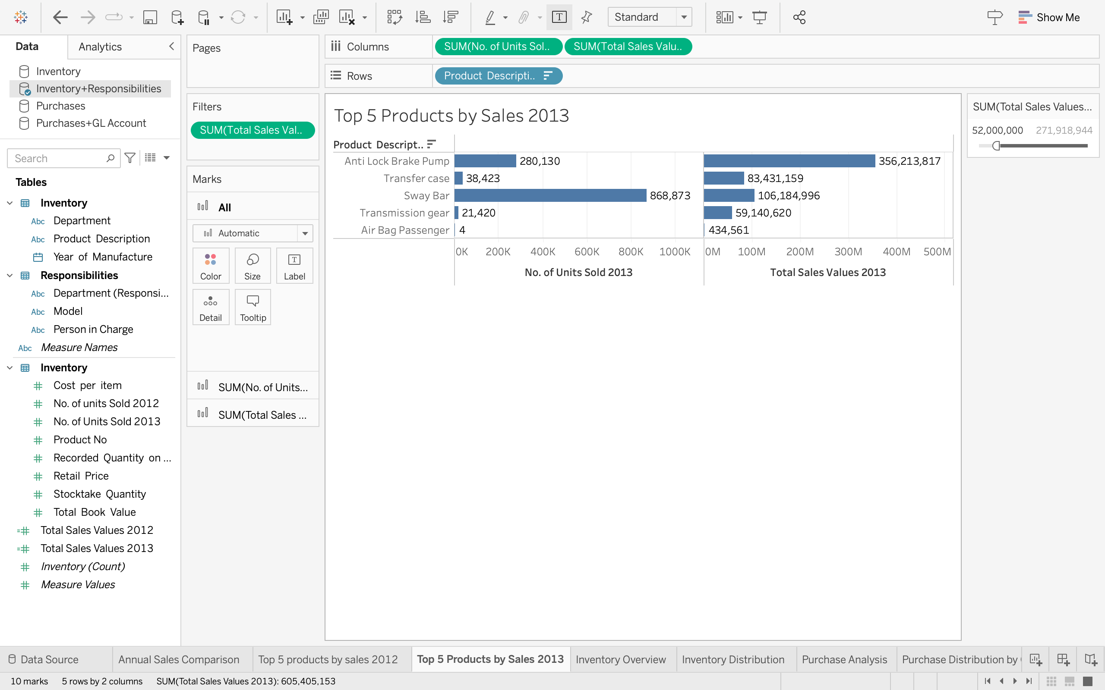

**Drag:**

* ‘Product Description’ to Rows and ‘No. of units Sold 2013’ & ‘TOTAL SALES VALUE 2013 ‘ to columns
* ‘No. of units Sold 2013’ & ‘TOTAL SALES VALUE 2013 ‘ TO COLORS
* CREATE FILTER WITH ‘TOTAL SALES VALUE 2013’ AND SELECT SHOW AT LEAST : ‘27000000> APPLY>OK
* THIS FILTER WILL ONLY SHOW TOP 5 RESULTS FOR BEST SALES VALUE BY PRODUCTS FOR 2012

# INSIGHTS

* WE CAN SEE THE TOP 5 PRODUCTS BY THEIR TOTAL SALES VALUE FOR 2013 INCLUDING THE NO. OF UNITS SOLD
* **SHEET 4: INVENTORY OVERVIEW:**

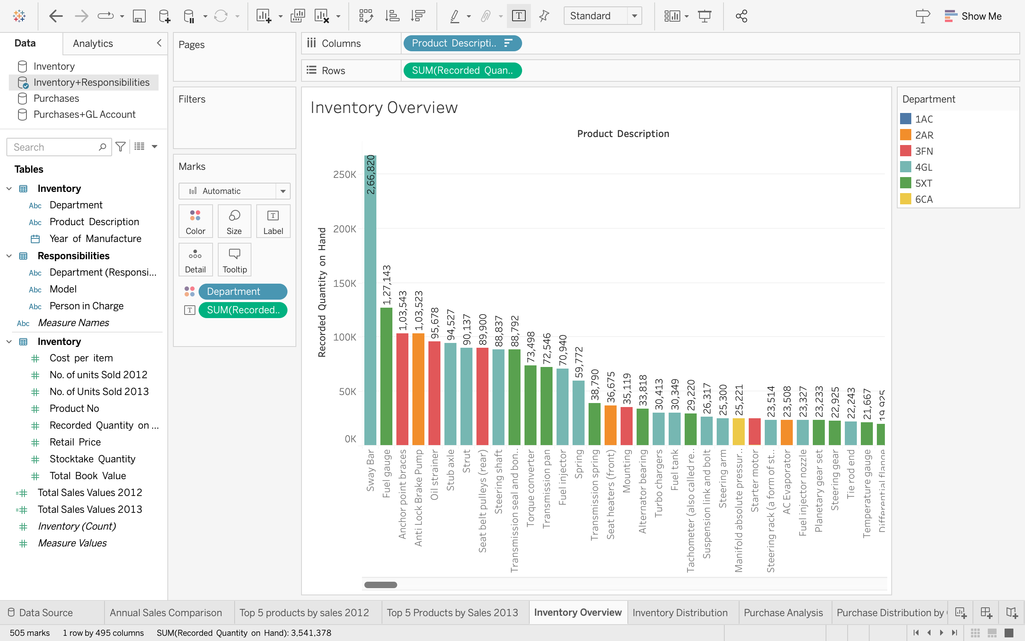

* PRODUCT DESCRIPTION IN COLUMNS
* SUM(RECORDED QUANTITY ON HAND) IN ROWS
* DEPARTMENT(RESPONSIBILITIES) TO COLOR
* SUM(RECORDED QUANTITY ON HAND) TO TEXT

**INSIGHTS**: THE ABOVE GRAPH SHOWS THE RECORDED QUANTITY AS PER THE PRODUCT DISTRIBUTION

# SHEET 5: INVENTORY DISTRIBUTION

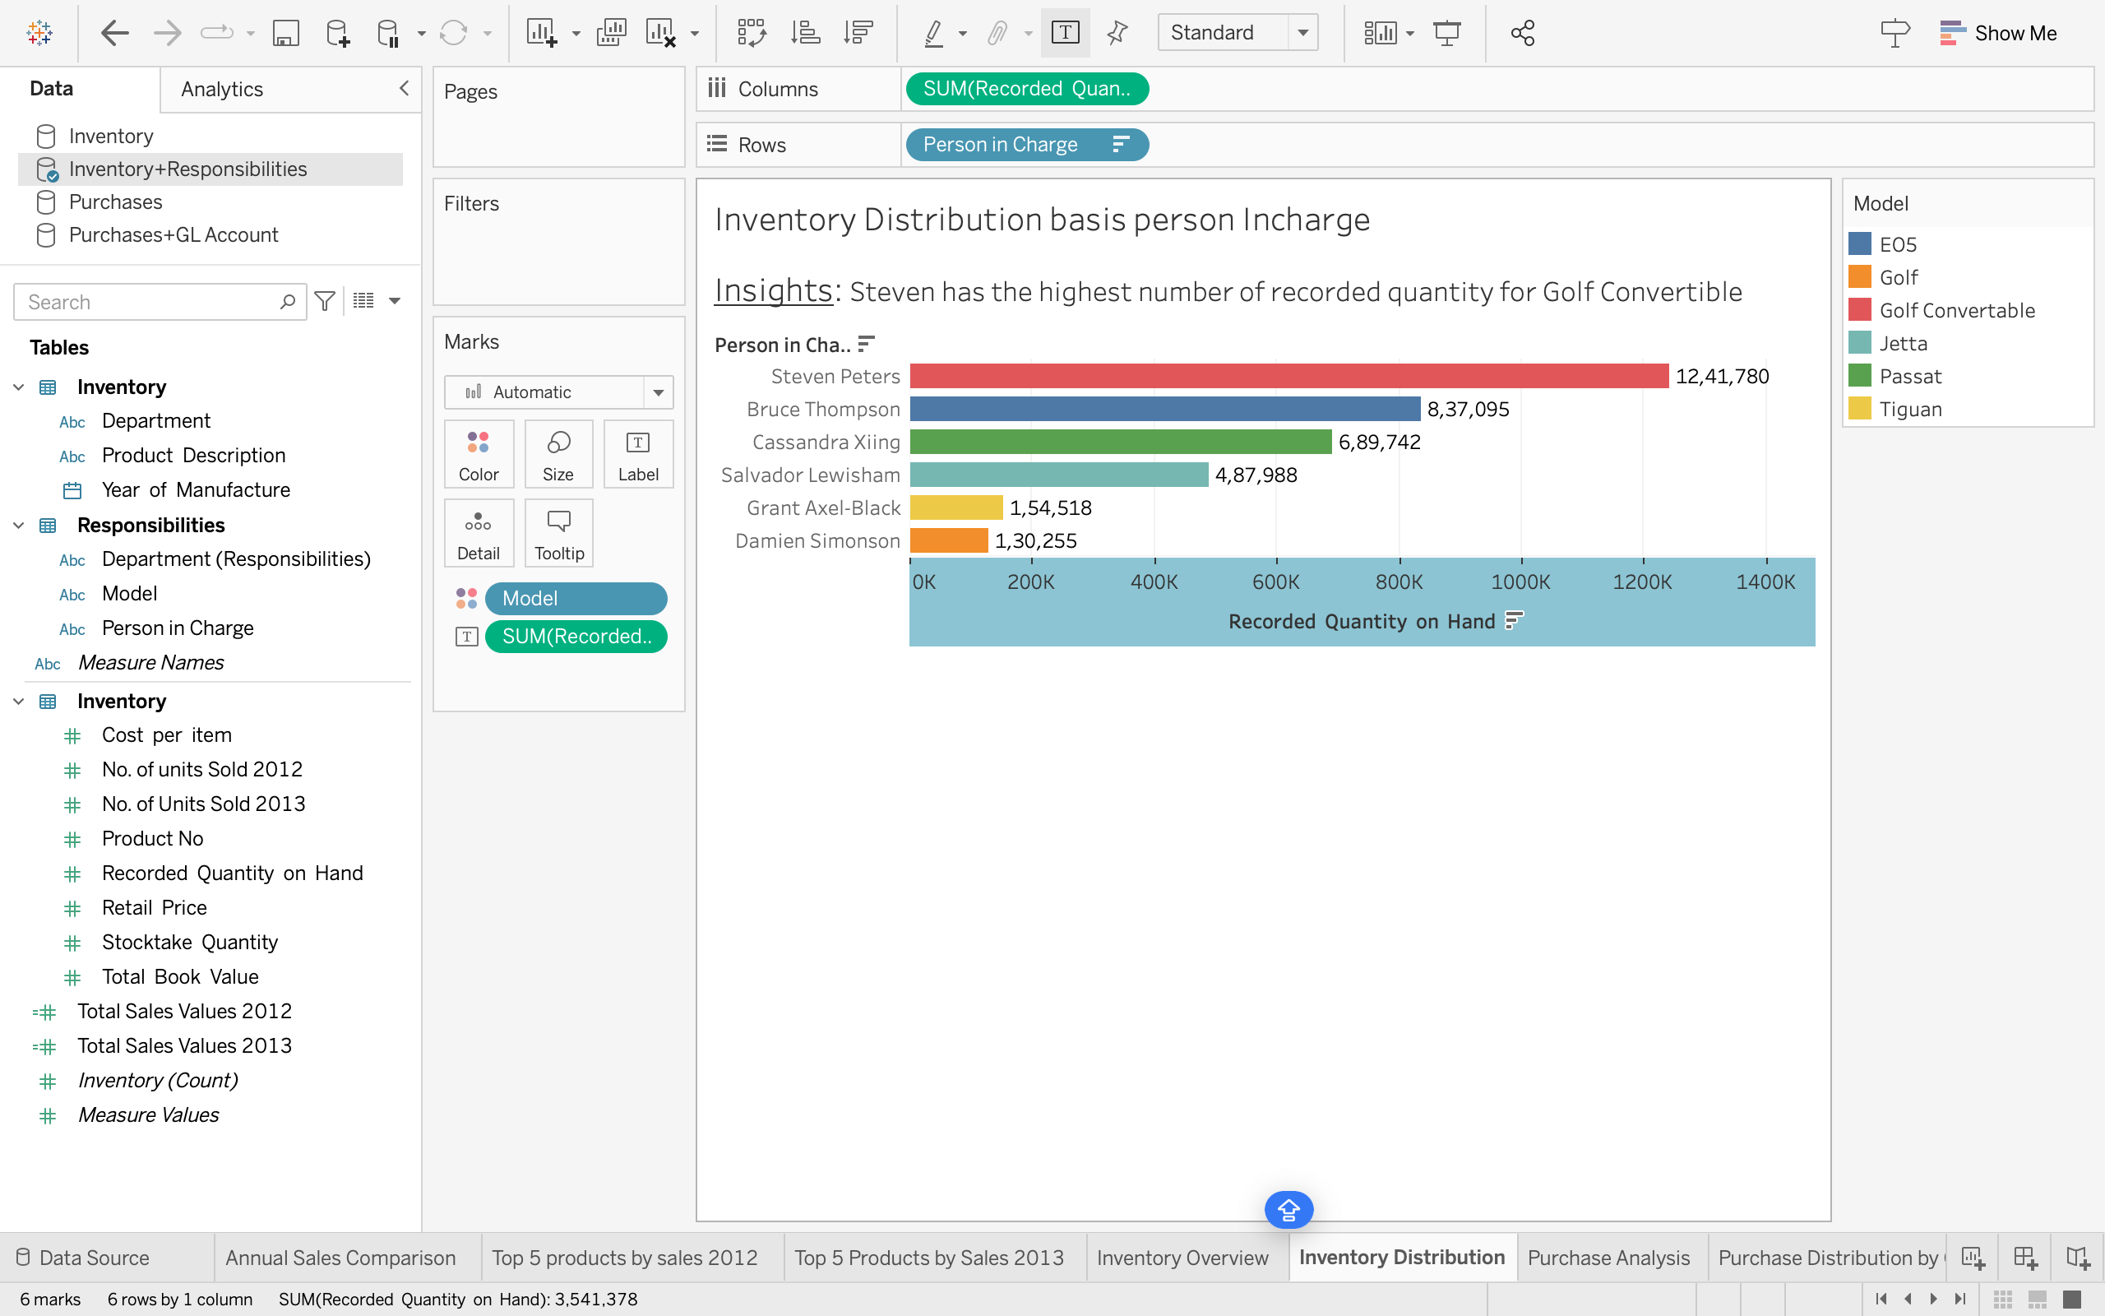

* SUM(RECORDED QUANTITY ON HAND) TO COLUMNS
* PERSON IN CHARGE TO ROWS
* MODEL TO COLORS
* SUM(RECORDED QUANTITY ON HAND) TO TEXT

**INSIGHTS**: STEVEN HAS THE HIGHEST NUMBER OF RECORDED QUANTITY FOR GOLF CONVERTIBLE

# SHEET 6: PURCHASE ANALYSIS

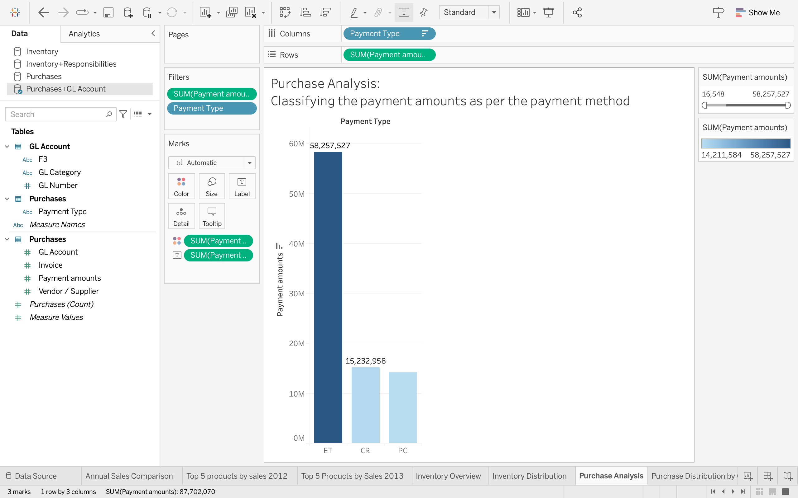

* + SUM(PAYMENT AMOUNTS) TO ROWS
  + SUM(PAYMENT AMOUNTS) TO FILTERS
  + SUM(PAYMENT AMOUNTS) TO COLORS
  + SUM(PAYMENT AMOUNTS) TO TEXT/LABEL
  + PAYMENT TYPE TO COLUMN AND FILTER
  + EDIT PAYMENT TYPE FILTER> SELECT NON-NULL VALUES ONLY
  + SELECT FILTER SUM(PAYMENT AMOUNTS)> SELECT NON-NULL VALUES ONLY FROM SPECIAL OPTION, CLICK APPLY AND OK.

**INSIGHTS:** THE HIGHEST PAYMENT HAS BEEN RECEIVED IN PAYMENT TYPE ET: ~60M USD

* + **Purchase Distribution by GL Category:**

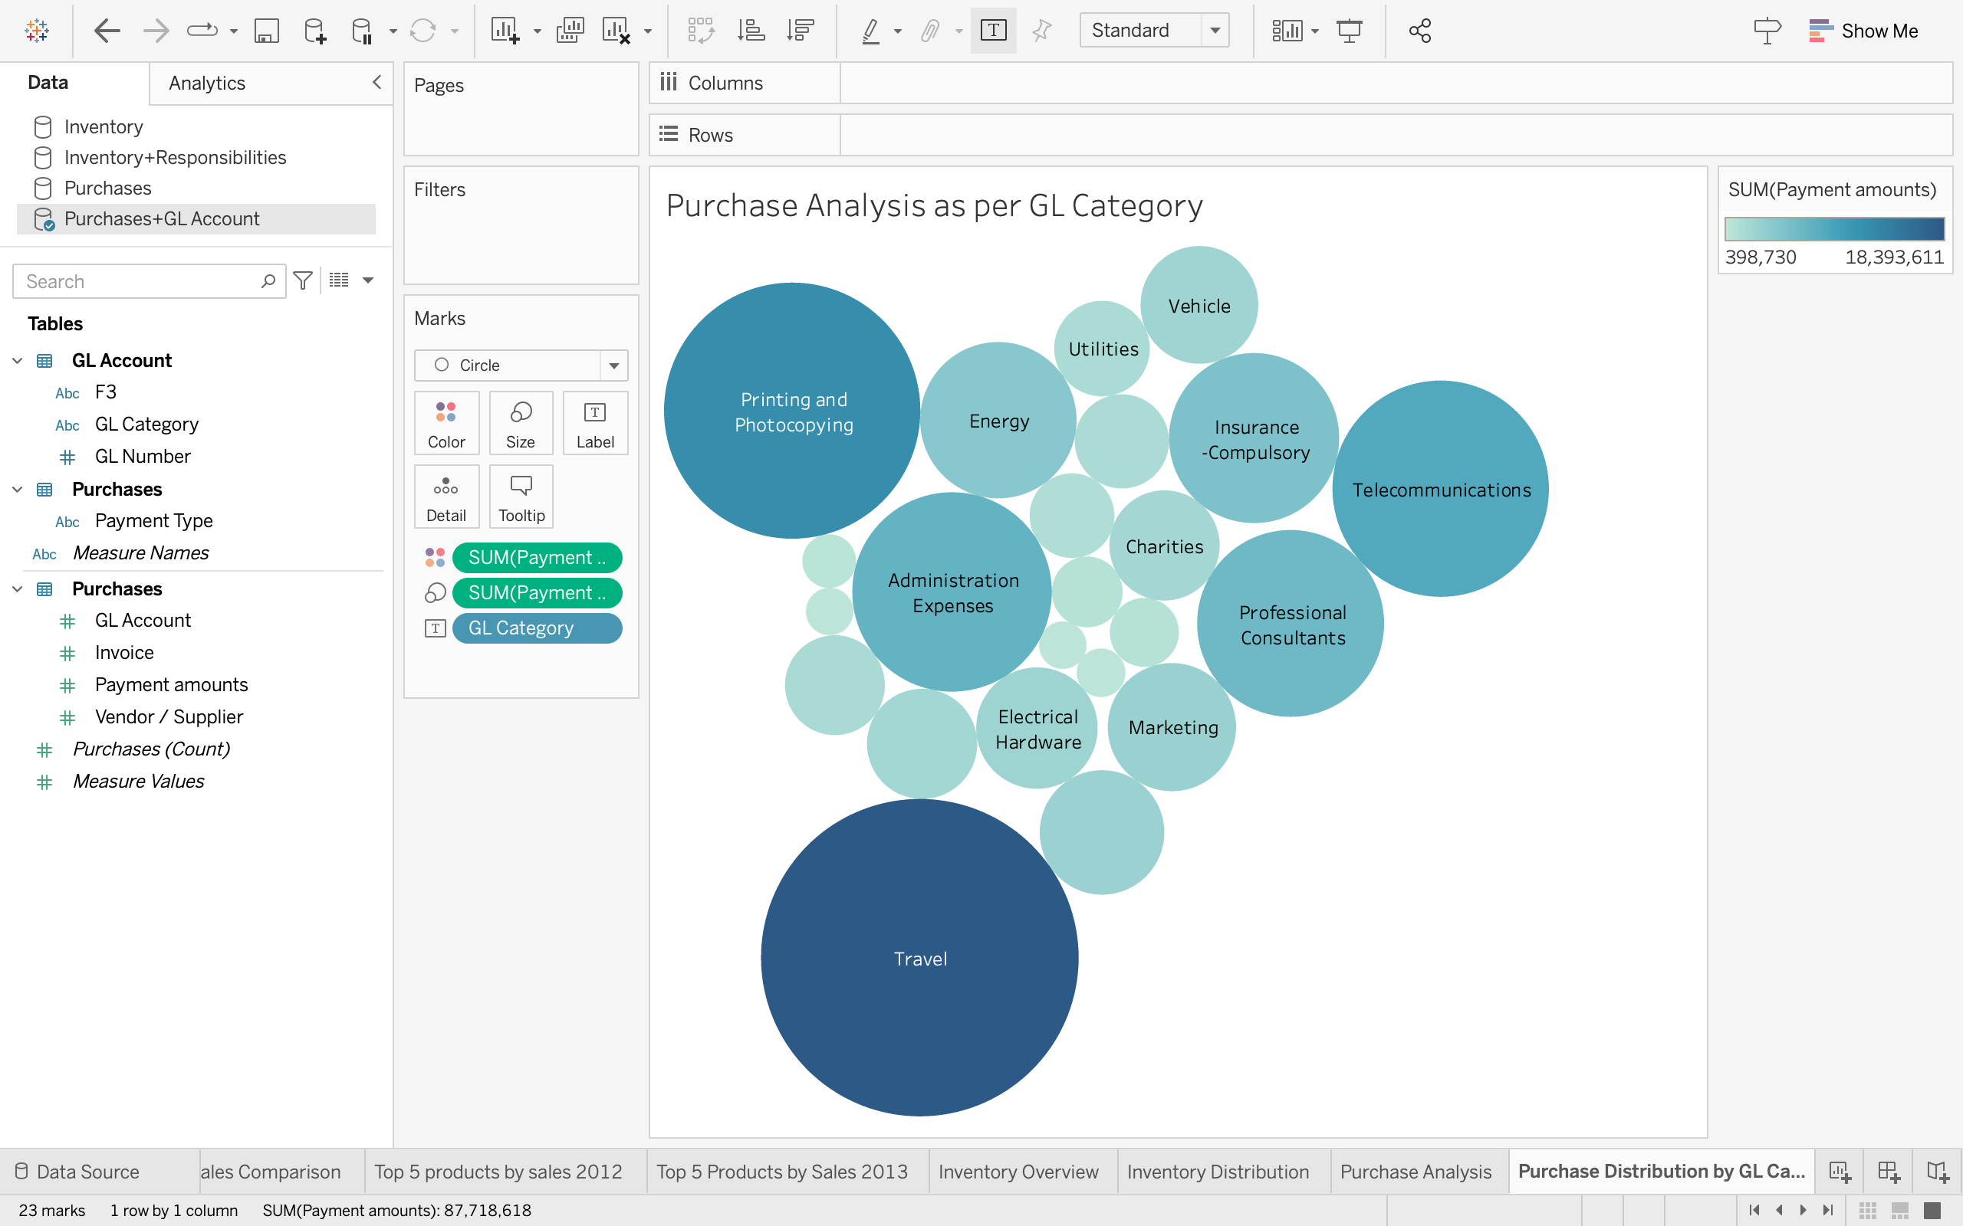

* + SUM(Payment amounts) TO COLORS
  + SUM(Payment amounts) TO SIZE
  + GL CATEGORY TO LABEL

**INSIGHT**: MAX PAYMENTS ARE RECEIVED FOR TRAVEL, ~18M, FOLLOWED BY PRINTING AND PHOTOCOPYING WITH 11M PAYMENT AMOUNT.